Great cloud of Witnesses: Church History
  - 2 June 2021 | Weeks 1-2: Persecution & Growth of the Early Church
Therefore, since we are surrounded by so great a cloud of witnesses, let us also lay aside every weight, and sin which clings so closely, and let us run with endurance the race that is set before us, ² looking to Jesus… - Hebrews 12:1-2a

Introduction: Why Study Church History?

  - Christianity is rooted in history (1 Cor. 15:1-11; Gal. 4:4-5)

  - God calls us to remember the past (Deut. 8:1-3; 1 Cor. 11:24-26)

  - All Christians share the same history (Gal. 3:7-8)

  - History prepares us for the future (Ecc. 1:9)

“Those who cannot remember the past are condemned to repeat it”
– George Santayana

“What has been is what will be,
and what has been done is what will be done,
and there is nothing new under the sun”. – Ecc. 1:19

  - History should humble us and protect us against pride

“Chronological snobbery…the uncritical acceptance of the intellectual climate common to our own age and the assumption that whatever has gone out of date is on that account discredited…” – C.S. Lewis

“The most recent is not necessarily the best. It is still on trial, and has yet to be assessed properly. – C.S. Lewis

  - History can embolden our evangelism

Caution: Avoid Two Historical Ditches
- Early Historical Context

  - Historical Context of Early Christianity

    - Greco-Roman Context

    - Jewish Context

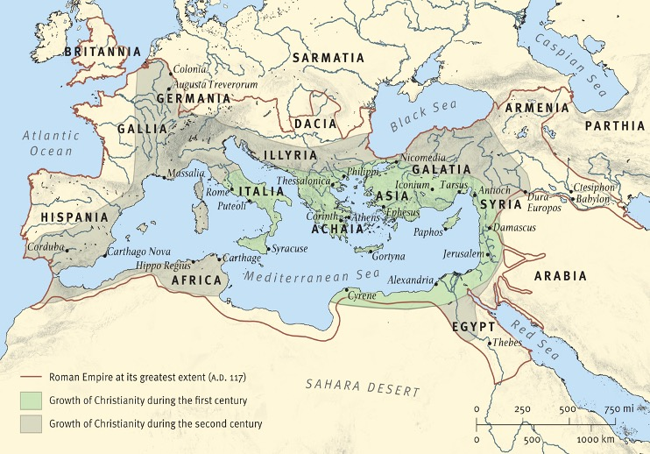

- First Century Persecution of Early Christians

  - Jewish Persecution

    - 34 A.D. First Christian Martyr: Stephan (Acts 7)

And there arose on that day a great persecution against the church in Jerusalem, and they were all scattered throughout the regions of Judea and Samaria…Now those who were scattered went about preaching the word - Acts 8:1,4

    - Persecution in Thessalonica (Acts 17)

    - Persecution & Martyrdom of the Apostles

      - James, son of Zebedee, beheaded (A.D. 41)

About that time Herod the king laid violent hands on some who belonged to the church. ² He killed James the brother of John with the sword, ³ and when he saw that it pleased the Jews, he proceeded to arrest Peter also. (Acts 12:1-2)

      - Paul beaten & arrested in Jerusalem (Acts 21:27-36)

      - James, the brother of Jesus killed (A.D. 62)

  - Roman Persecution

    - Emperor Nero (A.D. 52 – 68 A.D.)

      - Apostles Peter & Paul martyred

      - Rome & Christians Burn (A.D. 64)

“To kill the rumors, Nero charged and tortured some people hated for their evil practices – the group popularly called “Christians.” The founder of this sect, Christus, had been put to death by the governor of Judea, Pontius Pilate, when Tiberius was emperor.”

“First those who confessed to being Christians were arrested, and on the basis of their testimony a great number were condemned, although not so much for the fire itself as for their hatred of humankind. Before killing the Christians, Nero used them to amuse the people. Some were dressed in furs, to be killed by dogs. Others were crucified. Still others were set on fire early in the night, so that they might illumine it. Nero opened his own gardens for these shows.” - Tacitus

    - Key Event: Destruction of the Temple (A.D. 70)

      - Jewish revolt (A.D. 66)

      - Titus’ siege of Jerusalem (A.D. 70, April – September)

"in order that the Jewish and Christian religions might more completely be abolished; for although these religions were mutually hostile, they nevertheless sprung from the same founders; the Christians were an offshoot of the Jews, and if the root were taken away the stock would easily perish" Titus reported by Sulpicius Severus

    - Domitian (81-96)

      - Apostle John exiled to Patmos

      - Clement of Rome martyred.

- Continuing Roman Persecution & The Gift of Martyrdom

  - Notable Reigns of Persecution

    - Trajan (98-117)

    - Marcus Aurelius (161-180)

      - Martyrdom of Polycarp

    - Decius (249-251)

      - Instituted libelli, given to those who sacrificed to the Roman gods

    - Valerian (253-260)

      - Origen & Cyprian martyred

    - Diocletian (284-305)

      - The “Great Persecution” (303-312)

'If the Tiber river floods the city or if the Nile refuses to rise, or if the sky withholds its rain, if there is an earthquake, a famine, a pestilence, at once the cry is raised 'Christians to the lion"
– Tertullian

  - Why such great persecution?

    - Misunderstandings

    - Refusal to worship the Roman Emperor

    - Christian living was a constant condemnation to the Romans

    - Activity of Satan

  - Martyrdom: The Baptism of Blood

    - Martyr = witness unto death

    - Martyrdom as a spiritual gift

    - Dangers of Martyrdom

“And they have conquered him by the blood of the Lamb and by the word of their testimony, for they loved not their lives even unto death” - Rev. 12:11

- Expansion and Growth of Christianity

  - Jerusalem, Judea, Ends of the Earth

    - Antioch (250,000 Christians by

    - Rome (AD 250) - 30,000+ Christians lived in Rome most of them poor

    - North Africa

    - France (Lyons)

    - Britain (4th century)

"we have filled all that belongs to you – the cities, the fortresses, the free towns, the very camps, the palace, the senate, the forum. We leave [empty] only the [pagan] temples”

  - Who is getting saved?

“many in every period of life, on every level of society of both sexes...in towns and villages and scattered throughout the countryside" (A.D. 112)

  - What fueled the spread of Christianity?

    - God’s sovereign grace

    - Missionary zeal & bold witness

    - Christian charity

“See how these Christians love one another"

    - Value of individual human life

"We will not allow the image and creation of God to be thrown out to the wild beasts and the birds as their prey; it must be given back to the earth from which it was taken" - Lactanius, North African scholar (240-320)

"Atheism (Christianity) has been specially advanced through the loving service rendered to strangers, and through their care for the burial of the dead. It is a scandal that there is not a single Jew who is a beggar, and that the godless Galileans care not only for their own poor but for ours as well; while those who belong to us look in vain for help that we should render them" -Emperor Julian

    - Appeal of grace in a rigid stoic society

    - Historical providence and protection

- Critics & Creeds: Development in Early Church Theology & Practice

  - Early Church Practices

    - Lord’s Day Gathering

They were in the habit of meeting on a certain fixed day before it was light, when they sang an anthem to Christ as God, and bound themselves by a solemn oath not to commit any wicked deed, but to abstain from all fraud, theft and adultery, never to break their word, or deny a trust when called upon to honor it.” – Pliny the Younger to Emperor Tragan

‘On the day called the Day for the Sun all who live in cities or in the country gather together to one place, and the memoirs of the apostles or the writings of the prophets are read, as long as time permits; then when the reader has ceased the president verbally instructs, and exhorts to the imitation of these good things. Then we all rise together and pray"- Justin Martyr

    - Baptism & Lord’s Supper

    - The Didache

  - Emerging Church Governance

    - Ignatius (112)

"follow the bishop as Jesus Christ followed the father"

    - Irenaeus, Bishop of Lyons (185)

    - Cyprian, Bishop of Carthage (259)

"the bishop is in the Church and the Church is in the Bishop, and that if any one be not with the bishop he is not in the church"

  - Early Church Problems & Apologists

    - Emerging Heresies & Heretics

      - Gnosticism

      - Marcion

      - Montanus

“Every plank in the platform of orthodoxy was laid because some heresy had arisen that threatened to change the nature of Christianity and to destroy its central faith" (48)

    - Defending & Defining

      - The Apostles Creed/Old Roman Creed

      - Justin Martyr (Mtyr.165)

      - Origen (185-254)

"Far from us, say the Christians, be any man possessed of any culture or wisdom or judgement; their aim is to convince only worthless and contemptable people, idiots, slaves, poor women and children…These are the only ones whom they manage to turn into believers" - Celcus

      - Letter to Diognetus (~150-250)

- Key Dates & Events: Age of Catholic Christianity

  - Age of the Apostles (33 A.D. – 70 A.D.)

    - Jerusalem Temple Destroyed A.D. 70

  - Age of the Apostolic Fathers (70 A.D. – 150 A.D)

  - Age of the Apologists (150 A.D. – 250 A.D)

  - The “Great Persecution” (303-312)

…the gates of hell shall not prevail… - Matt. 16:18

Resources Cited & Recommended

Primary Sources

Letter of Pliny the Younger to Emperor Tajan: http://www.tyrannus.com/pliny_let.html

Letter to Diognetus: http://facweb.furman.edu/~ateipen/diognet.html

Books & Articles
Core Seminars: Capitol Hill Baptist. Core Seminars | Capitol Hill Baptist | Church History: Hades' Gates Won't Prevail. (2016, June 1). https://www.capitolhillbaptist.org/resources/core-seminars/series/church-history/.
Early, Joseph. (2015). A history of Christianity: an introductory survey. Nashville, TN: B&H Publishing Group.
ESV study Bible: English Standard Version. (2011). Wheaton, IL: Crossway.
Haykin, Michael A. G. (2011). Rediscovering the Church Fathers Who They Were and How They Shaped the Church. Crossway.
Noll, M. A. (2012). Turning points: decisive moments in the history of Christianity. Baker Academic.
Shelley, B. L. (2008). Church history in plain language. 3rd Edition. Thomas Nelson.

Cornelius Tacitus, The Annals: The Reigns of Tiberius, Claudius, and Nero, Oxford World’s Classics (Oxford ; New York: Oxford University Press, 2008), 359.
Pliny the Younger, Letters x.96. AD112

